Homologous Recombination Deficiency (HRD) Score Predicts Response to Platinum-Containing Neoadjuvant Chemotherapy in Patients with Triple Negative Breast Cancer

Supplemental Materials

Extraction of DNA from frozen and FFPE tumors
A 5 micron H&E slide was created and reviewed by a pathologist to facilitate enrichment of tumor derived DNA. When extracting DNA from frozen tumors, 2-5 10 micron sections were cut and regions of highest tumor cell density were scraped from the slide. DNA was extracted using the Promega Maxwell 16 LEV Blood DNA kit (AS1290) (Promega, Madison, WI). Macro-dissected frozen tissue was incubated overnight at 56°C with proteinase K and lysis buffer in a shaking heat block. After the overnight incubation, undigested material was removed by centrifugation and the Maxwell cartridges were loaded. gDNA was eluted in 60 μL of water.
For extraction of DNA from FFPE tumors, 10 micron sections were cut and regions of highest tumor cell density were scraped from the slide. The Promega Maxwell 16 LEV FFPE Plus DNA extraction kit (AS1135) (Promega, Madison, WI) was used to extract DNA. FFPE macro-dissected slices were incubated overnight at 70°C with 20μL Proteinase K and 180μL Incubation buffer in a shaking heat block. After the overnight incubation, an additional 20μL of Proteinase K was added and additional digestion occurred for 3 hours at 70°C. RNA was digested using 10μL RNase A (A7973) (Promega, Madison, WI) at 37°C for 20min following tissue digestion. 420 μL Lysis buffer was then added to the samples, and Maxwell cartridges were loaded. gDNA was eluted in 110μL of water.

BRCA1 Methylation
An additional 100ng genomic DNA was subjected to bisulfite conversion using the EpiTect Bisulfite kit (Qiagen). PCR primers specific for bisulfite converted DNA were used to amplify the promoter region of exon 1A of the 5’ untranslated region of the BRCA1 gene. The resulting PCR products were sequenced using a MiSeq (Illumina, San Diego, CA) sequencer. Sequence reads were aligned to the BRCA1 promoter amplicon and the called base at ten CpG sites was inspected. The number of CpG site bases with a “C” nucleotide was counted; this represents the number of methylated CpG sites. A methylation score for the sample was computed as the proportion of methylated reads relative to the total number of reads that were either methylated or not methylated. Samples with methylation score >10% were classified as methylated.
TAI, LST, and LOH Calculation
TAI, LST, and LOH were calculated as described by Timms et al.[1], which includes modifications from the initial reporting of TAI and LST calculations. For samples analyzed by MIP assay, allele intensities from CEL files were used to generate allelic imbalance profiles. A hidden Markov model (HMM) was used to define regions and breakpoints with these profiles. Allele specific copy number (ASCN) for each of the regions was determined using an algorithm similar to that described by Popova et al. [2]. TAI (number of regions of allelic imbalance that extend to one of the subtelomeres but do not cross the centromere) and LST (number of break points between regions longer than 10 Mb after filtering out regions shorter than 3 Mb) scores were calculated using the allelic imbalance profiles, while LOH (number of subchromosomal LOH regions longer than 15 Mb) was calculated using ASCN.
HRD Score Calculation
To calculate the HRD score based on SNP data, noise to signal ratio (NSR) for SNP data was used as a quality metric. Noise was calculated as the standard deviation of allele dosage for informative SNPs (SNPs that are heterozygous in normal DNA). Signal was calculated as the weighted average of the difference in allele dosage between adjacent regions with weights defined as 1/S1+1/S2, where S1 and S2 are sizes of the adjacent regions. By comparing HRD scores between samples run in duplicate, a cutoff of 0.85 for NSR was established. Samples with NSR below 0.85 were considered passing HRD scores.
Statistical methods:
In order to evaluate the predictive ability of HRD compared to other available clinical information, we fit a series of three logistic regression models where clinical stage, tBRCA1/2 mutation status, and dichotomous HRD score were added one variable at a time (Table S6). In each model, cohort was included as a covariate in order to adjust for possible confounding. P-values were based on a likelihood ratio test for the models with and without the variable of interest and show the significance of adding each variable. In the full model, interaction between tBRCA1/2 mutation status and dichotomous HRD score was also tested. ROC curves for each model were drawn using predicted probabilities from these models (Fig S4). Differences between paired ROC curves were tested with the DeLong method [3].

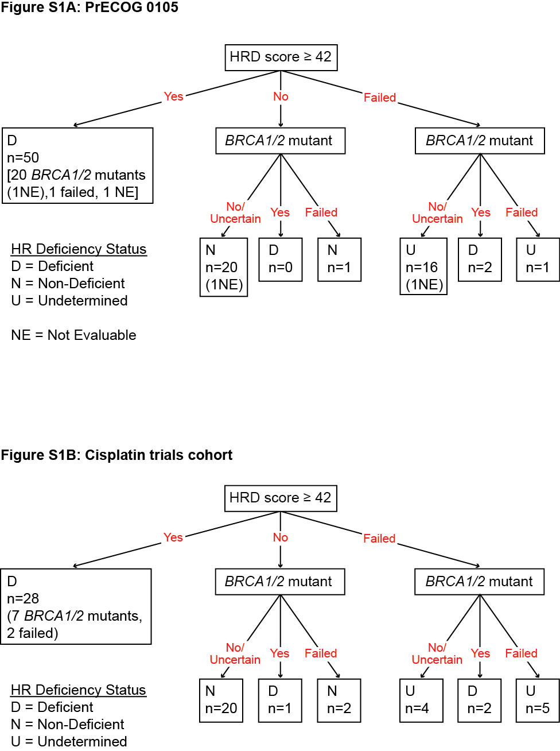
Figure S2. Distribution of all passing HRD scores in (A) PrECOG 0105 cohort, n= 68 and (B) the cisplatin trials cohort, n=48.

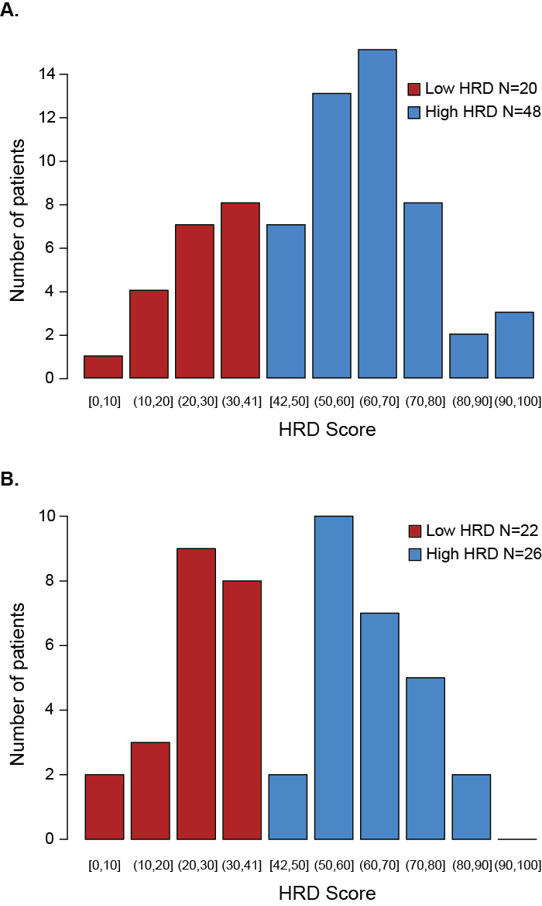

Figure S3. Performance of the HRD Score in predicting (A) RCB 0/1 response or (B) pCR in the combined PrECOG 0105 and Cisplatin trials.

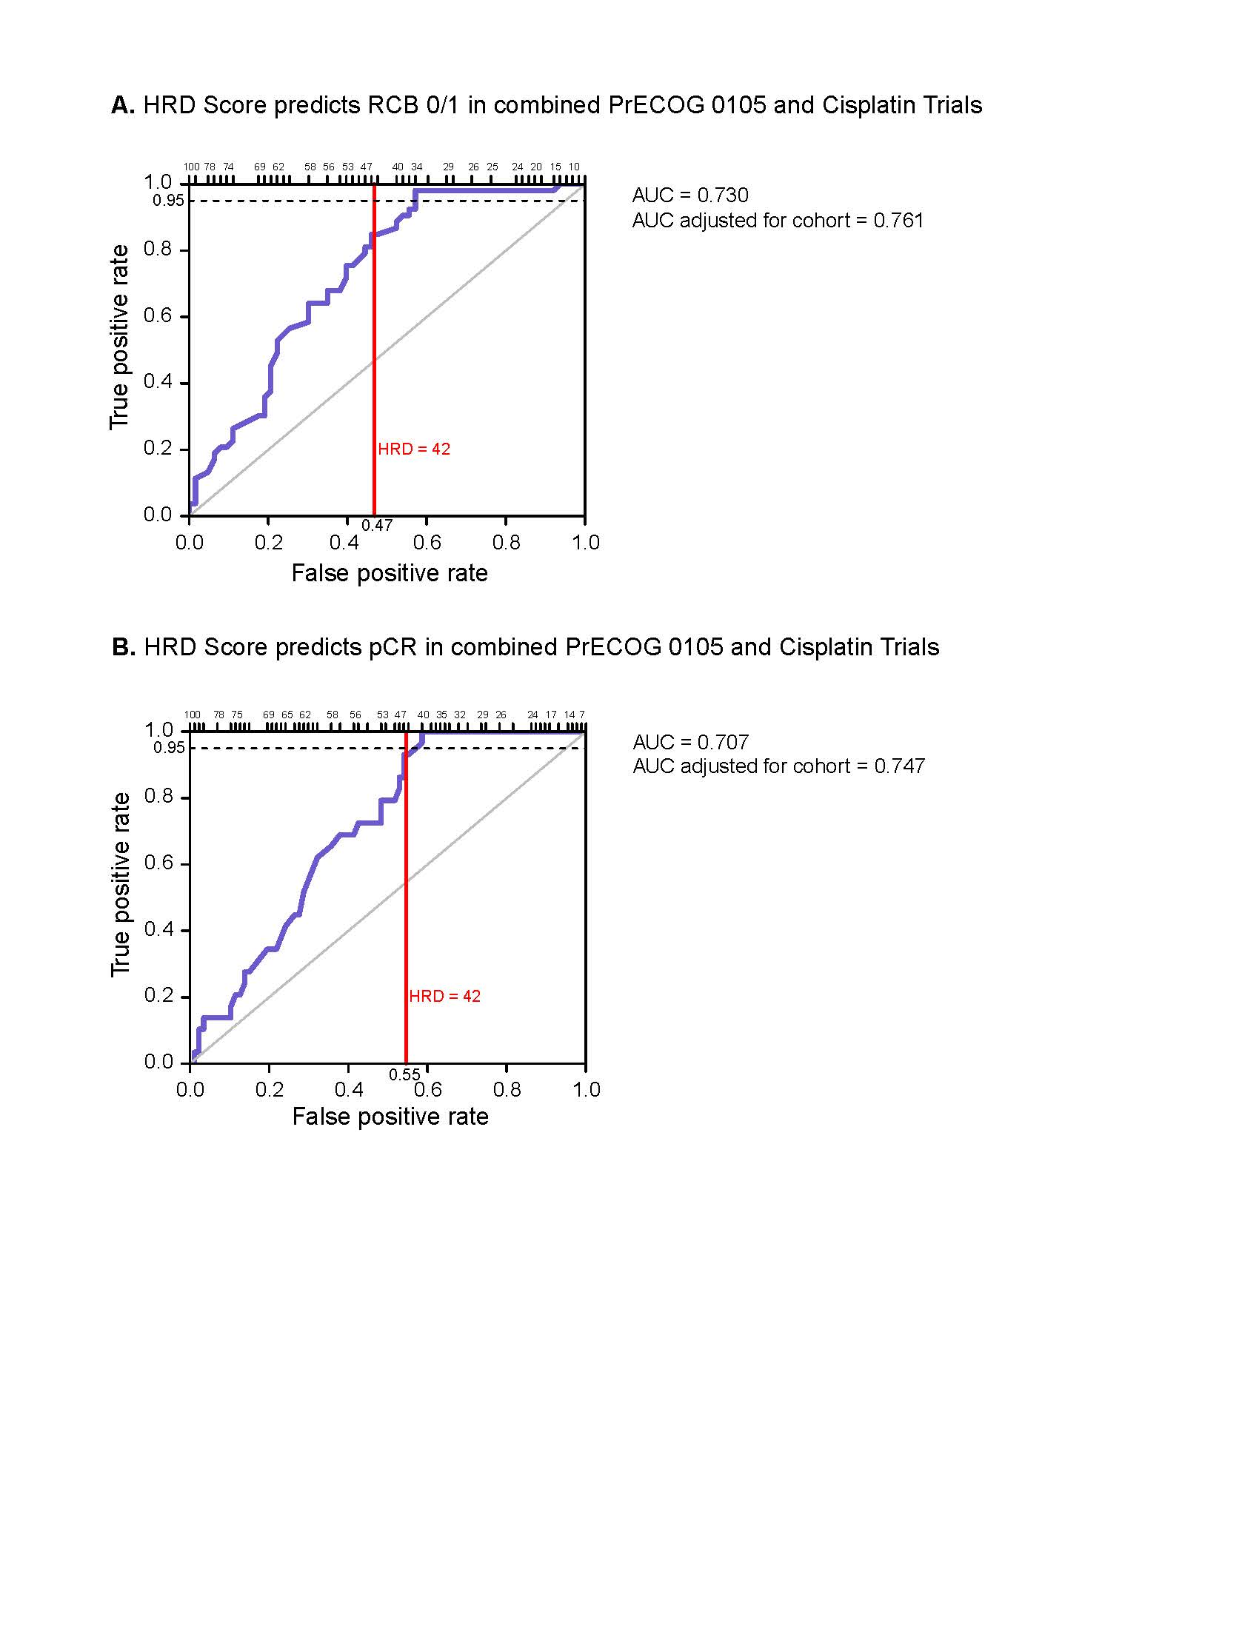
Figure S4. Logistic regression models to predict (A) RCB 0/1 and (B) pCR in combined PrECOG 0105 and Cisplatin Trials cohorts. One-sided p-values testing addition of each term.

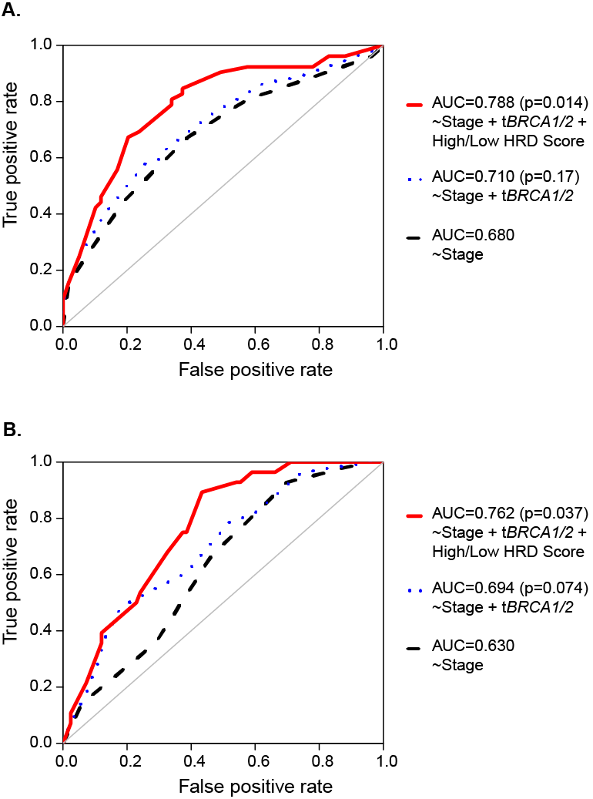

Table S1. Study cohorts for threshold training set
Reference | Tissue | Number of BRCA1/2 deficient samples | Number of BRCA1/2 intact samples
Hennessy et al. [4] | Ovarian | 44 (34.6%) | 83 (65.4%)
TCGA_OvCa [5] | Ovarian | 146 (33.6%) | 288 (66.4%)
TCGA_BrCa [6] | Breast | 41 (13.9%) | 254 (86.1%)
Timms et al. [1] | Breast | 37 (18.3%) | 165 (81.7%)

Table S2. Summary statistics of HRD scores in BRCA1/2 deficient samples by tissue in training set.
Tissue | 5th percentile | Minimum | 1st quartile | Median | Mean | 3rd quartile | Maximum
Breast | 41.9 | 11 | 54 | 62 | 61.5 | 70 | 96
Ovarian | 42.9 | 23 | 56 | 64 | 63.0 | 70.8 | 96
Breast and Ovarian | 42.0 | 11 | 55 | 64 | 62.6 | 70 | 96

Table S3. Patient clinical and demographic data
A. HRD Subset of PrECOG0105
Variable | Levels | N | Summary Statistics
Age at diagnosis (years) |  | 70 | Mean: 49.1  IQR: 41.5-56.0
Grade | II | 17 | 24%
 | III | 53 | 76%
Stage | IA | 9 | 13%
 | IIA | 26 | 37%
 | IIB | 25 | 36%
 | IIIA | 10 | 14%
ER | 0% | 57 | 81%
 | 1-90% | 13 | 19%
PR | 0% | 59 | 84%
 | 1-30% | 11 | 16%
Histology | Invasive ductal carcinoma | 68 | 97%
 | Poorly differentiated carcinoma | 2 | 3%
RCB class | 0 | 23 | 33%
 | I | 17 | 24%
 | II | 19 | 27%
 | III | 6 | 9%
 | III-PD | 5 | 7%
Chemotherapy* | 4 cycles | 11 | 16%
 | 6-cycles | 59 | 84%
Race/Ethnicity | Asian | 8 | 11%
 | Black or African-American | 4 | 6%
 | Hispanic or Latino | 2 | 3%
 | White | 33 | 47%
B. HRD subset of Cisplatin Trials Cohort
Variable | Levels | N | Summary Statistics
Age at diagnosis (years) |  | 50 | Mean: 49.8  IQR: 43.0-56.8
Grade | II (2) or II-III (2) | 4 | 8%
 | III | 46 | 92%
Tumor size (cm) |  | 50 | Mean: 3.7  IQR: 2.7-4.0
Baseline nodal status | Negative | 27 | 54%
 | Positive | 23 | 46%
Stage | IIA | 25 | 50%
 | IIB | 21 | 42%
 | IIIA | 4 | 8%
RCB class | 0 | 8 | 16%
 | I | 9 | 18%
 | II | 22 | 44%
 | III | 11 | 22%
Chemotherapy | Cisplatin | 18 | 36%
 | Cisplatin + Bevacizumab | 32 | 64%

Table S4. HRD score and association with therapy response in entire cohorts
A. PrECOG 0105 Cohort (N = 68)
Quantitative HRD Score
Responder | N | Mean (sd) | Odds ratio per IQR* (95% CI) | Logistic p-value
RCB 0/1 = no | 30 | 45.4 (22.7)
RCB 0/1 = yes | 38 | 59.0 (17.2) | 2.63 (1.26, 5.48) | 0.0061
pCR = no | 46 | 50.2 (23.1)
pCR = yes | 22 | 59.0 (13.6) | 1.85 (0.88, 3.88) | 0.093
HRD Score: High vs. Low
Responder | HRD high  Number  (% response) | HRD low  Number  (% response) | Odds ratio  (95% CI) Reference = low HRD score | Logistic p-value
RCB 0/1 = no | 16 | 14
RCB 0/1 = yes | 32 (67%) | 6 (30%) | 4.67 (1.51, 14.4) | 0.0053
pCR = no | 28 | 18
pCR = yes | 20 (42%) | 2 (10%) | 6.43 (1.34, 30.9) | 0.0065
B. Cisplatin Trials Cohort (N = 48)
Quantitative HRD Score
Responder | N | Mean (sd) | Odds ratio per IQR** (95% CI) | Logistic p-value
RCB 0/1 = no | 33 | 39.8 (20.8)
RCB 0/1 = yes | 15 | 62.9 (16.1) | 10.5 (2.3, 48.6) | 3.1 x 10⁻⁴
pCR = no | 41 | 42.6 (20.3)
pCR = yes | 7 | 73.3 (11.4) | 117 (2.9, 4764) | 7.0 x 10⁻⁵
HRD Score: High vs. Low
Responder | HRD high  Number  (% response) | HRD low  Number  (% response) | Odds ratio  (95% CI) Reference = low HRD score | Logistic p-value
RCB 0/1 = no | 13 | 20
RCB 0/1 = yes | 13 (50.0%) | 2 (9%) | 10.0 (1.93, 51.8) | 0.0014
pCR = no | 19 | 22
pCR = yes | 7 (26.9%) | 0 (0%) | 17.3 (1.90, 2300)† | 0.0071†
*IQR=28 in PrECOG 0105 cohort
**IQR=37.5 in cisplatin trials cohort
†Based on Firth’s penalized profile likelihood

Table S5. Univariate associations between clinical variables and RCB 0/1 or HR deficiency status
A. PrECOG 0105 Cohort
 |  |  | HR Deficiency Status |  |  |  | Association with RCB 0/1
Categorical Variable | Levels |  | Deficient | Non-Deficient | Association with HR deficiency: logistic p-value N=70 | HRD Score Mean (sd) N=68 | Odds ratio  (95% CI) | Logistic p-value  N=70
Grade | II |  | 10 | 7 | 0.20 | 47.9 (23.3) | Reference
 | III |  | 40 | 13 |  | 54.6 (20.0) | 1.25 (0.42, 3.76) | 0.69
Stage | IA |  | 5 | 4 | 0.21 | 51.0 (22.7) | 6.86 (0.75, 63.0)
 | IIA |  | 21 | 5 |  | 54.4 (15.0) | Reference | 0.056
 | IIB |  | 19 | 6 |  | 56.8 (23.6) | 1.29 (0.42, 3.91)
 | IIIA |  | 5 | 5 |  | 40.7 (23.0) | 0.37 (0.08, 1.74)
Chemo-therapy | 4 cycles |  | 7 | 4 | 0.54 | 48.9 (21.0) | Reference | 0.85
 | 6 cycles |  | 43 | 16 |  | 53.8 (20.9) | 1.13 (0.31, 4.13)
 |  |  | HR Deficiency Status |  |  |  | Association with RCB 0/1
Quantitative variable |  | N | Deficient mean (sd) | Non-Deficient  mean (sd) | Association with HR deficiency: logistic p-value | Pearson correlation with HRD score: rho, p-value N=68 | Odds ratio per IQR = 14  (95% CI) | Logistic p-value
Age at diagnosis |  | 70 | 46.1 (10.3) | 56.4  (9.2) | 2.0x10-4 | -0.34  0.0049 | 0.50 (0.26, 0.97) | 0.031
B. Cisplatin Trials Cohort
 |  |  | HR Deficiency Status |  |  |  | Association with RCB 0/1
Categorical Variable |  | Levels | Deficient | Non-Deficient | Association with HR deficiency: logistic p-value N=50 | HRD Score Mean (sd) N=48 | Odds ratio  (95% CI) | Logistic p-value  N=50
Grade |  | II | 2 | 2 | 0.74 | 33.3 (33.7) | Reference | 0.49
 |  | III | 27 | 19 |  | 48.0 (21.3) | 0.48 (0.06, 3.78)
Baseline nodal status |  | Negative | 15 | 12 | 0.70 | 46.5 (22.4) | Reference | 0.19
 |  | Positive | 14 | 9 |  | 47.8 (22.1) | 2.20 (0.67, 7.24)
Stage |  | IIA | 14 | 11 |  | 45.7 (21.1) | Reference
 |  | IIB | 13 | 8 |  | 49.2 (24.6) | 2.37 (0.67, 8.38)
 |  | IIIA | 2 | 2 | 0.87 | 45.2 (19.6) | 3.17 (0.36, 27.6) | 0.31
Chemo-therapy |  | Cisplatin | 12 | 6 | 0.35 | 49.2 (19.3) | Reference | 0.48
 |  | Cisplatin + Bevacizumab | 17 | 15 |  | 45.8 (23.8) | 1.56 (0.44, 5.47)
 |  |  | HR Deficiency Status |  |  |  | Association with RCB 0/1
Quantitative variable |  | N | Deficient mean (sd) | Non-Deficient  mean (sd) | Association with HR deficiency: logistic p-value | Pearson correlation with HRD score: rho, p-value N=48 | Odds ratio per IQR  (95% CI) | Logistic p-value
Age at diagnosis |  | 50 | 47.5 (9.5) | 53.0 (8.6) | 0.037 | -0.26,  0.077 | 0.54 (0.22, 1.33) | 0.17
Tumor size |  | 50 | 3.6 (1.3) | 3.8 (1.7) | 0.73 | 0.037,  0.80 | 1.28 (0.76, 2.15) | 0.35

Table S6. Analysis of RCB 0/1 and pCR in combined PrECOG 0105 and Cisplatin Trials cohorts (logistic regression models adjusted for cohort)
A. Stage
 |  |  | RCB 0/1 |  |  |  | pCR
Variable | Levels | Number of patients (%) | %  RCB 0/1 |  | Odds ratio  (95% CI) | p-value | % pCR |  | Odds ratio  (95% CI) | p-value
Cohort | PrECOG 0105 | 70 (58%) | 57 |  | Reference |  | 33 |  | Reference
 | Cisplatin trials | 50 (42%) | 34 |  | 0.45  (0.20, 0.98) | 0.041 | 16 |  | 0.39  (0.15, 1.00) | 0.044
Clinical  Stage | IA | 9 (8%) | 89 |  | 8.49  (0.96, 75.5) |  | 44 |  | 1.56  (0.35, 7.03)
 | IIA | 51 (43%) | 39 |  | Reference |  | 25
 | IIB | 46 (38%) | 52 |  | 1.68  (0.74, 3.82) |  | 26 |  | 1.00  (0.40, 2.54)
 | IIIA | 14 (12%) | 36 |  | 0.73  (0.21, 2.56) | 0.061 | 14 |  | 0.40  (0.08, 2.09) | 0.55
B. Stage and tBRCA1/2 mutation status
 |  |  |  | RCB 0/1 |  |  |  | pCR
Variable | Levels | Number of patients (%) | % RCB 0/1 |  | Odds ratio  (95% CI) | p-value | % pCR |  | Odds ratio†  (95% CI) | p-value
Cohort | PrECOG 0105 | 68 (59%) | 57 |  | Reference |  | 32 |  | Reference
 | Cisplatin trials | 47 (41%) | 36 |  | 0.55  (0.24, 1.26) | 0.16 | 17 |  | 0.50  (0.19, 1.33) | 0.16
Clinical  Stage | IA | 9 (8%) | 89 |  | 8.77  (0.95, 81.2) |  | 44 |  | 1.55  (0.32, 7.46)
 | IIA | 48 (42%) | 40 |  | Reference |  | 25
 | IIB | 45 (39%) | 53 |  | 1.87  (0.78, 4.44) |  | 27 |  | 1.12  (0.42, 2.97)
 | IIIA | 13 (11%) | 38 |  | 0.91  (0.24, 3.40) | 0.081 | 15 |  | 0.50  (0.09, 2.75) | 0.72
tBRCA1/2 Mutation Status | Wild type | 84 (73%) | 40 |  | Reference |  | 19
 | Mutant | 31 (27%) | 71 |  | 3.34  (1.32, 8.50) | 0.0089 | 45 |  | 3.14  (1.26, 7.85) | 0.015
C. Stage, tBRCA1/2 mutation status, and dichotomous HRD score †
 |  |  | RCB 0/1 |  |  |  | pCR
Variable | Levels | Number of patients (%) | % RCB 0/1 |  | Odds ratio  (95% CI) | p-value | % pCR |  | Odds ratio†  (95% CI) | p-value
Cohort | PrECOG 0105 | 66 (59%) | 56 |  | Reference |  | 32 |  | Reference
 | Cisplatin trials | 45 (41%) | 33 |  | 0.64  (0.26, 1.59) | 0.34 | 16 |  | 0.58  (0.20, 1.65) | 0.30
Clinical  Stage | IA | 9 (8%) | 89 |  | 24.4  (2.15, 278) |  | 44 |  | 3.05  (0.49, 19.0)
 | IIA | 47 (42%) | 38 |  | Reference |  | 23 |  | Reference
 | IIB | 43 (39%) | 51 |  | 1.91  (0.74, 4.90) |  | 26 |  | 1.14  (0.40, 3.20)
 | IIIA | 12 (11%) | 33 |  | 1.09  (0.24, 4.91) | 0.015 | 17 |  | 0.84  (0.14, 5.05) | 0.65
tBRCA1/2 Mutation Status | Wild type | 84 (76%) | 40 |  | Reference |  | 19 |  | Reference
 | Mutant | 27 (24%) | 67 |  | 1.33  (0.47, 3.82) | 0.59 | 44 |  | 1.56  (0.55, 4.38) | 0.40
HRD Score | Low (<42) | 39 (35%) | 21 |  | Reference |  | 5 |  | Reference
 | High (≥42) | 72 (65%) | 61 |  | 7.70  (2.50, 23.7) | 8.3x10-5 | 36 |  | 9.31  (1.84, 47.1) | 0.0011

References

1. Timms KM, Abkevich V, Hughes E, Neff C, Reid J, Morris B, et al. Association of BRCA1/2 defects with genomic scores predictive of DNA damage repair deficiency among breast cancer subtypes. Breast Cancer Res. 2014;16:475.
2. Popova T, Manie E, Rieunier G, Caux-Moncoutier V, Tirapo C, Dubois T, et al. Ploidy and large-scale genomic instability consistently identify basal-like breast carcinomas with BRCA1/2 inactivation. Cancer Res. 2012;72:5454-62.
3. DeLong ER, DeLong DM, Clarke-Pearson DL. Comparing the areas under two or more correlated receiver operating characteristic curves: a nonparametric approach. Biometrics. 1988;44:837-45.
4. Hennessy BT, Timms KM, Carey MS, Gutin A, Meyer LA, Flake DD, 2nd, et al. Somatic mutations in BRCA1 and BRCA2 could expand the number of patients that benefit from poly (ADP ribose) polymerase inhibitors in ovarian cancer. J Clin Oncol. 2010;28:3570-6.
5. Integrated genomic analyses of ovarian carcinoma. Nature. 2011;474:609-15.
6. Comprehensive molecular portraits of human breast tumours. Nature. 2012;490:61-70.

